**CSCI 1100 – Fall 2016**

**Assignment 1 – Due Sunday Oct. 23 at 11:00 pm (night time)**

**Submit on Brightspace**

**Name: Mihyar Al-Masalma**

**Student ID:** B00759975

**Assignments are to be your own work. If you have questions, you can ask your Instructor, course TAs, or TAs in the Learning Centre.**

|  |  |  |
| --- | --- | --- |
| **Declaration: Please complete this declaration** | | |
| 1 | “This document is entirely my own work.” If no, acknowledge any assistance below; outside help should only be used to help you understand the questions NOT to provide the solutions. | Yes |
| 2 | I obtained help to complete this document (e.g., from a TA). | No. |
| 3 | This document contains some guidance from the Internet or another document or file or program (e.g., Java's API). | Yes. Went to stack overflow to get info about why nextInt is not consuming the whole line:  http://stackoverflow.com/questions/13102045/scanner-is-skipping-nextline-after-using-next-nextint-or-other-nextfoo |

**Question 1.** Write a Java application that displays a triangle 4 lines high, made up of two different numbers. The program will ask a user to input two numbers: one between 0 and 4 and one between 5 and 9. The first and third line of the triangle will be filled with the first number; the second and last line of the triangle will be filled with the second number.

***Sample output:***

Input a number between 0-4: 2

Input a number between 5-9: 6

2

6 6

2 2 2

6 6 6 6

Provide a printout of properly formatted source code (your entire Java program).

/* Assignment1 Question 1

This program will show a pyramid of 4 lines alternating between two

values the user enter.

<CSCI 1100><Mihyar Al-Masalma><B00759975>*/

import java.util.Scanner; // import Scanner class

public class Q1{

public static void main(String[] args) {

// Create an instance from the Scanner class

Scanner input = new Scanner(System.in);

// Ask user to enter a number

System.out.print("Input a number between 0-4: ");

// Store the value the user entered in a variable

int first = input.nextInt();

// Ask user to enter the second value

System.out.print("Input a number between 5-9: ");

// Store the value the user entered in a variable

int second = input.nextInt();

// Print out the pyramid

System.out.println(" "+first+" ");

System.out.println(" "+second+" "+second+" ");

System.out.println(" "+first+" "+first+" "+first+" ");

System.out.println(second+" "+second+" "+second+" "+second);

}

}

Provide 2 example outputs/test cases.

Input a number between 0-4: 3

Input a number between 5-9: 6

3

6 6

3 3 3

6 6 6 6

Input a number between 0-4: 0

Input a number between 5-9: 9

0

9 9

0 0 0

9 9 9 9

**Question 2.** Write a Java application that displays an upside down triangle 4 lines high, made up of one of two possible characters: *asterisk* [*] **OR** *Dollar Sign* [$]. The program will ask a user to enter one number between 1 and 10. If the number is odd, the triangle will be made up of asterisks; if the number is even it will be made up of $ characters. (Hint – look at the modulus operator to help you!)

***Sample outputs:***

Input a number between 1-10: 7

* * * *

* * *

* *

*

Provide a printout of properly formatted source code (your entire Java program).

/* Assignment1 Question 2

This program will print out a pyramid of dollar signs if the number is even

and pyramid of astriks if the number is odd

<CSCI 1100><Mihyar Al-Masalma><B00759975>*/

import java.util.Scanner; // importing Scanner class

public class Q2 {

public static void main(String[] args) {

// Create an instance of the Scanner class

Scanner input = new Scanner(System.in);

// Ask the user to eneter a value between 1 and 10

System.out.print("Input a number between 1-10: ");

// Store the inserted value in a variable

int num = input.nextInt();

// Check if the number is Odd

if (num%2!=0) {

// if it is snowing then print pyramid of Astriks

System.out.println("* * * *");

System.out.println(" * * * ");

System.out.println(" * * ");

System.out.println(" * ");

}else{

// if it is not odd then print pyramid of dollar signs

System.out.println("$ $ $ $");

System.out.println(" $ $ $ ");

System.out.println(" $ $ ");

System.out.println(" $ ");

}

}

}

Provide 2 example outputs/test cases: one that shows a printout of asterisks and one that shows a printout of $ characters.

Input a number between 1-10: 5

* * * *

* * *

* *

*

Input a number between 1-10: 6

$ $ $ $

$ $ $

$ $

$

**Question 3.** Write a Java application that plays a word game with the user. The program asks the user to enter the following:

* Your name
* One number between 1 and 10
* Your favorite sport
* Your hometown
* Your favorite movie
* Your favorite animal

Once the user enters these items, the program will display one of two stories depending on what number they entered. If the number they entered is less than 5 it will print the following by replacing the inputted variables into the correct locations:

THIS IS THE BEST STORY EVER

My name is <name>. And I'm from <hometown>.

My favorite sport is <sport>. I have a pet <animal>

who I take to watch my favorite movie <movie>.

The End!

If the number they entered is 5 or greater, it will print the following:

THIS IS THE BEST STORY EVER

My name is <name> and I am a <animal>. I live in <hometown> and love to watch <movie> while trying to play <sport>. It does not work out so well though.

The End!

Here is a sample run. Words in orange are user input from the keyboard.

Enter your name: Bob

Enter a number from 1 to 10: 7

Enter your favorite sport: hockey

Enter your hometown: Halifax

Enter your favorite movie: Star Wars

Enter your favorite animal: snake

THIS IS THE BEST STORY EVER

My name is Bob and I am a snake. I live in Halifax and love to watch Star Wars while trying to play hockey. It does not work out so well though.

The End!

Provide a printout of properly formatted source code (your entire Java program).

/* Assignment1 Question 3

this program will ask a user to enter different information then

print out a story made of these information

<CSCI 1100><Mihyar Al-Masalma><B00759975>*/

import java.util.Scanner; // Import Scanner class

public class Q3 {

public static void main(String[] args) {

// Create an instance of the scanner class

Scanner input = new Scanner(System.in);

// Ask the user to enter his name

System.out.print("Enter your name: ");

// Store the value the user entered in a variable

String name = input.nextLine();

// Ask the user to enter a number

System.out.print("Enter a number from 1 to 10: ");

// Store the value the user entered in a variable

int num = input.nextInt();

// this is to consume the rest of the line

input.nextLine();

// Ask the user to enter favorite sport

System.out.print("Enter your favorite sport: ");

// Store the value the user entered in a variable

String sport = input.nextLine();

// Ask the user to enter his hometown

System.out.print("Enter your hometown: ");

// Store the value the user entered in a variable

String hometown = input.nextLine();

// Ask the user to enter his favorite movie

System.out.print("Enter your favorite movie: ");

// Store the value the user entered in a variable

String movie = input.nextLine();

// Ask the user to enter favorite animak

System.out.print("Enter your favorite animal: ");

// Store the value the user entered in a variable

String animal = input.nextLine();

if (num < 5) {

// if the number is less than 5 then print this story

System.out.println("THIS IS THE BEST STORY EVER");

System.out.println("My name is "+name+" and I'm from "+hometown+".");

System.out.print("My favorite sport is "+sport+". I have a pet "+animal+"\nwho");

System.out.println(" I take to watch my favorite movie "+movie+".");

System.out.println("The End!");

}else{

// if the number is greater than 5 then print this story

System.out.println("\nTHIS IS THE BEST STORY EVER");

System.out.print("My name is "+name+" and I am a "+animal+".");

System.out.println(" I live in "+hometown+" and love to watch "+movie+" while");

System.out.println("trying to play "+sport+". it does not work out so well though");

System.out.println("The End!");

}

}

}

Provide 2 example output/test cases (to show both stories).

Enter your name: Racquel

Enter a number from 1 to 10: 3

Enter your favorite sport: Wrestling

Enter your hometown: Hubbards

Enter your favorite movie: The Hunger Games

Enter your favorite animal: Red Panda

THIS IS THE BEST STORY EVER

My name is Racquel and I'm from Hubbards.

My favorite sport is Wrestling. I have a pet Red Panda

who I take to watch my favorite movie The Hunger Games.

The End!

Enter your name: Adelaide

Enter a number from 1 to 10: 5

Enter your favorite sport: Softball

Enter your hometown: Trenton

Enter your favorite movie: Saving Private Ryan

Enter your favorite animal: Cats

THIS IS THE BEST STORY EVER

My name is Adelaide and I am a Cats. I live in Trenton and love to watch Saving Private Ryan while

trying to play Softball. it does not work out so well though

The End!

**Question 4.** Write a program that will calculate the cost of airline ticket for Air Canada. There is a special sale on flights for students and senior citizens. If a person is a student there is a 20% discount; and if a person is a senior citizen there is a 10% discount. If a person is neither a student nor a senior citizen, no discount applies to their ticket price.

Use a Scanner object to read in the regular price of an airline ticket plus the sales tax rate on the ticket (e.g., the HST rate), and find out if the person flying is a student or a senior citizen. You will apply the discount (if applicable) to the cost of the ticket BEFORE adding the tax. After you apply the discount, then apply the tax and print the total. See the sample below for proper formatting of the output. *Do not concern yourself with controlling the display of the decimal point.*

Sample 1:

Enter the price of the flight: $ 300

Enter the tax rate: % 10

Enter 1 for student, 2 for senior, or 3 for neither: 1

Discount on price of ticket: $60.0

Price of ticket (after discount): $240.0

Tax: $24.0

Total: $264.0

Sample 2:

Enter the price of the flight: $ 300

Enter the tax rate: % 10

Enter 1 for student, 2 for senior, or 3 for neither: 3

Discount on price of ticket: $0.0

Price of ticket (after discount): $300.0

Tax: $30.0

Total: $330.0

Provide a printout of properly formatted source code (your entire Java program).

/* Assignment1 Question 4

Thiss program should take a ticket price, tax, discount and

if the passenger is a child or senior citizen and then return

how much the passenger have to pay.

<CSCI 1100><Mihyar Al-Masalma><B00759975>*/

import java.util.Scanner; //import Scanner Class

public class Q4 {

public static void main(String[] args) {

// Define varirables to use later

double discount = 0, newPrice, tax, total;

// Create an instance of the Scanner class

Scanner input = new Scanner(System.in);

// Ask the user to enter the price of the flight

System.out.print("Enter the price of the flight: $");

// Store the value in a variable called ticket

double ticket = input.nextDouble();

// Ask the user to enter the tax rate

System.out.print("Enter the tax rate: %");

// Store the value in variable called taxPercentage

double taxPercentage = input.nextDouble();

// Ask the user to choice the category

System.out.print("Enter 1 for student, 2 for senior, or 3 for neither: ");

// store the value in a variable called choice

int choice = input.nextInt();

// to consume what is left of the line

input.nextLine();

// Evaluate the user choice

if (choice == 1) {

// if student then discount is 20%

discount = ticket * 0.20;

}else if(choice == 2){

// if senior then discount is 10%

discount = ticket * 0.10;

}

// if neither discount is 0 which we already initiate with

// compute the new price after discount

newPrice = ticket - discount;

// Calculate the tax

tax = newPrice / taxPercentage;

// Calculate how much the client should pay

total = newPrice + tax;

// print out the results

System.out.println("Discount on price of ticket: $"+discount);

System.out.println("Price of ticket (after discount): $"+newPrice);

System.out.println("Tax: $"+tax);

System.out.println("Total: $"+total);

}

}

Provide 3 example outputs/test cases different than above: one that shows a printout of the sale of ticket for a student, a senior and a person who is neither a student nor a senior.

Enter the price of the flight: $500

Enter the tax rate: %10

Enter 1 for student, 2 for senior, or 3 for neither: 1

Discount on price of ticket: $100.0

Price of ticket (after discount): $400.0

Tax: $40.0

Total: $440.0

Enter the price of the flight: $600

Enter the tax rate: %15

Enter 1 for student, 2 for senior, or 3 for neither: 2

Discount on price of ticket: $60.0

Price of ticket (after discount): $540.0

Tax: $36.0

Total: $576.0

Enter the price of the flight: $800

Enter the tax rate: %10

Enter 1 for student, 2 for senior, or 3 for neither: 3

Discount on price of ticket: $0.0

Price of ticket (after discount): $800.0

Tax: $80.0

Total: $880.0

**Question 5**. Create a Java program that asks the user to enter four numbers between 0-9, then checks to see how many pairs of numbers there are (in any order). There can be 0 pairs, 1 pair, or 2 pairs. Once a number is assigned to a pair, it cannot be used to form a different pair. For example:

If the user enters 0 1 0 1 the output would be 2 pair.

If the user enters 9 9 5 5 the output would be 2 pair.

If the user enters 9 9 9 9 the output would be 2 pair.

If the user enters 9 9 9 5 the output would be 1 pair.

If the user enters 3 2 1 3 the output would be 1 pair.

If the user enters 5 6 7 1 the output would be 0 pair.

If the user enters 1 0 1 1 the output would be 1 pair.

See below for a sample of runs.

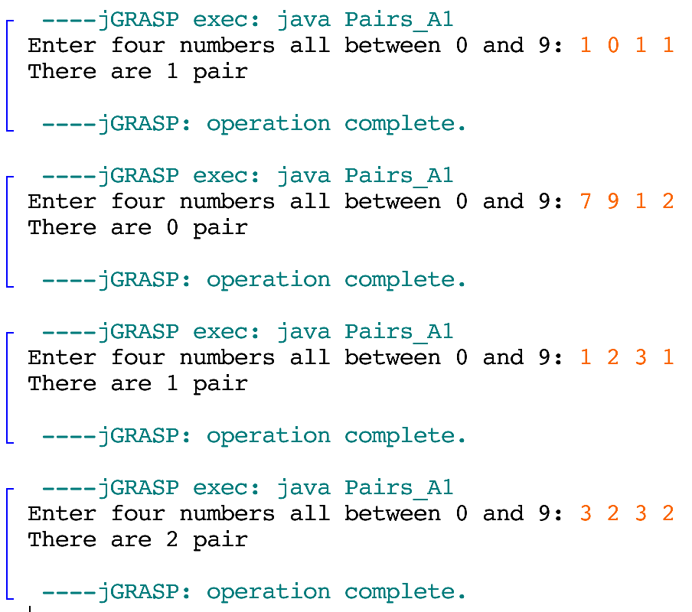

Provide a printout of properly formatted source code (your entire Java program).

/* Assignment1 Question 5

This program will take a 4 numbers input seperated by space

then calculate how many pairs there is

<CSCI 1100><Mihyar Al-Masalma><B00759975>*/

import java.util.Scanner; // import Scanner class

public class Q5 {

public static void main(String[] args) {

// define a variable to store the number of pairs

int pairs = 0;

// Create an instance of the Scanner object

Scanner input = new Scanner(System.in);

// Ask the user to enter the numbers

System.out.print("Enter four numbers all between 0 and 9: ");

// Store the numbers in 4 different variables

int num1 = input.nextInt();

int num2 = input.nextInt();

int num3 = input.nextInt();

int num4 = input.nextInt();

// consume the rest of the line

input.nextLine();

// Ckeck if the first two numbers is a pair

if (num1 == num2) {

// check if the other two numbers is a pair

if(num3 == num4){

// if yes then we have 2 pairs

pairs = 2;

}else{

// if no then we have one pair

pairs = 1;

}

// Check if the first and third number is a pair

}else if(num1 == num3){

// check if the other two numbers is a pair

if (num2 == num4) {

// if yes then we have 2 pairs

pairs = 2;

}else{

// if no then we have on pair

pairs = 1;

}

// Check if the first and fourth number is a pair

}else if (num1 == num4) {

// Check if the other two is a pair

if (num2 == num3) {

// if yes then we have two pairs

pairs = 2;

}else{

// if no then we have one pair

pairs = 1;

}

// Check if the 2nd and 3rd numbers are pair

}else if (num2 == num3) {

// if yes then we have one pair

pairs = 1;

// Check if 2nd and 4th number is a pair

}else if (num2 == num4) {

// if yes then we have a pair

pairs = 1;

}else if (num3 == num4) {

// if yes then we have one pair

pairs = 1;

}

// Print out the result

System.out.println("There are "+pairs+" pair");

}

}

Provide 4 example outputs/test cases: showing all four possibilities – no pairs, 1 pair, 2 pairs and a case with 1 pair when three numbers match.

Enter four numbers all between 0 and 9: 1 2 3 4

There are 0 pair

Enter four numbers all between 0 and 9: 1 2 1 1

There are 1 pair

Enter four numbers all between 0 and 9: 0 0 9 9

There are 2 pair

Enter four numbers all between 0 and 9: 5 5 5 9

There are 1 pair

**Question 6.** Write a Java program that uses a Scanner object to read in three numbers and determines the smallest and largest numbers *without* using Java's Math Class.

Ask a user to enter three numbers. Then print the sum of the three numbers, the largest of the three numbers and the smallest of the three numbers. Finally, print all three numbers from largest to smallest. See the sample below for proper formatting of the output. *Do not concern yourself with controlling the display of the decimal point.* **You can assume all three numbers are different.**

Sample:

Enter three numbers: 22 10 30

The sum of 22.0, 10.0, and 30.0 is 62.0

The largest number is 30.0

The smallest number is 10.0

The numbers from largest to smallest are: 30.0, 22.0, and 10.0

Provide a printout of properly formatted source code (your entire Java program).

/* Assignment1 Question 6

This program will take three numbers as argument seperated

by spaces then return the largest, the smallest and then

return it arranged by the largest

<CSCI 1100><Mihyar Al-Masalma><B00759975>*/

import java.util.Scanner; // import Scanner class

public class Q6 {

public static void main(String[] args) {

// Create an instance of the Scanner class

Scanner input = new Scanner(System.in);

// Ask eht user to enter the numbers

System.out.print("Enter three numbers: ");

// Store the numbers in vairables

double num1 = input.nextDouble();

double num2 = input.nextDouble();

double num3 = input.nextDouble();

// consume the rest of the line

input.nextLine();

// Calculate the sum of the numbers

double sum = num1 + num2 + num3;

// Print out the sum of the numbers

System.out.println("The sum of "+num1+", "+num2+" and "+num3+" is "+sum);

// Assume the first number is the largest

double largest = num1;

if (num2>largest) {

// if 2nd number is bigger assign the 2nd number to the largest

largest = num2;

}

if(num3 > largest){

// if the 3rd number is bigger assign it to largest

largest = num3;

}

// Print out the largest number

System.out.println("The largest number is "+ largest);

// Assume the first number is the smallest

double smallest = num1;

if (num2<smallest) {

// if 2nd number is smaller then assign it to the smallest

smallest = num2;

}

if (num3<smallest) {

// if 3rd number is smaller then assign it to the smallest

smallest = num3;

}

// print out the smallest number

System.out.println("The smallest number is "+ smallest);

// define a new variable

double rest;

if (num1 != largest && num1 != smallest) {

// if the 1st number is neither largest nor smallest it is the rest

rest = num1;

}else if (num2 != largest && num2 != smallest) {

// else if the 2nd number is neither largest nor smallest it is the rest

rest = num2;

}else{

// else the rest is 3rd number

rest = num3;

}

// print out the numbers arranged

System.out.println("The numbers from largest to smallest are: " +largest+", "+rest+", and "+smallest);

}

}

Provide 3 example outputs/test cases (different from above that shows all possible cases).

Enter three numbers: 11 22 33

The sum of 11.0, 22.0 and 33.0 is 66.0

The largest number is 33.0

The smallest number is 11.0

The numbers from largest to smallest are: 33.0, 22.0, and 11.0

Enter three numbers: 44 42 41

The sum of 44.0, 42.0 and 41.0 is 127.0

The largest number is 44.0

The smallest number is 41.0

The numbers from largest to smallest are: 44.0, 42.0, and 41.0

Enter three numbers: 15 50 5

The sum of 15.0, 50.0 and 5.0 is 70.0

The largest number is 50.0

The smallest number is 5.0

The numbers from largest to smallest are: 50.0, 15.0, and 5.0